**Section 194 of The Bharatiya Nagarik Suraksha Sanhita (BNSS):**

**Police to enquire and report on suicide etc.**

(1) When the officer in charge of a police station or some other police officer specially empowered by the State Government in that behalf receives information that a person has committed suicide, or has been killed by another or by an animal or by machinery or by an accident, or has died under circumstances raising a reasonable suspicion that some other person has committed an offence, he shall immediately give intimation thereof to the nearest Executive Magistrate empowered to hold inquests, and, unless otherwise directed by any rule made by the State Government, or by any general or special order of the District or Sub-divisional Magistrate, shall proceed to the place where the body of such deceased person is, and there, in the presence of two or more respectable inhabitants of the neighbourhood, shall make an investigation, and draw up a report of the apparent cause of death, describing such wounds, fractures, bruises, and other marks of injury as may be found on the body, and stating in what manner, or by what weapon or instrument (if any); such marks appear to have been inflicted.

(2) The report shall be signed by such police officer and other persons, or by so many of them as concur therein, and shall be forwarded to the District Magistrate or the Sub-divisional Magistrate within twenty-four hours.

(3) When—

(i) the case involves suicide by a woman within seven years of her marriage; or

(ii) the case relates to the death of a woman within seven years of her marriage in any circumstances raising a reasonable suspicion that some other person committed an offence in relation to such woman; or

(iii) the case relates to the death of a woman within seven years of her marriage and any relative of the woman has made a request in this behalf; or

(iv) there is any doubt regarding the cause of death; or

(v) the police officer for any other reason considers it expedient so to do,

he shall, subject to such rules as the State Government may prescribe in this behalf, forward the body, with a view to its being examined, to the nearest Civil Surgeon, or other qualified medical person appointed in this behalf by the State Government, if the state of the weather and the distance admit of its being so forwarded without risk of such putrefaction on the road as would render such examination useless.

(4) The following Magistrates are empowered to hold inquests, namely, any District Magistrate or Sub-divisional Magistrate and any other Executive Magistrate specially empowered in this behalf by the State Government or the District Magistrate

**Section 173 in Bharatiya Nagarik Suraksha Sanhita, 2023**

**It deal with cognizable cases and e-FIR**

173. Information in cognizable cases.

Every information relating to the commission of a cognizable offence, irrespective of the area **where the offence is committed, may be given orally or by electronic communication to an officer in charge of a police station,** and if given-

(i) orally, it shall be reduced to writing by him or under his direction, and be read over to the informant; and every such information, whether given in writing or reduced to writing as aforesaid, shall be signed by the person giving it;

(ii) by electronic communication, it shall be taken on record by him on being signed within three days by the person giving it, and the substance thereof shall be entered in a book to be kept by such officer in such form as the State Government may by rules prescribe in this behalf:

Provided that if the information is given by the woman against whom an offence under section 64, section 65, section 66, section 67, section 68, section 69, section 70, section 71, section 74, section 75, section 76, section 77, section 78, section 79 or section 124 of the Bharatiya Nyaya Sanhita, 2023 is alleged to have been committed or attempted, then such information shall be recorded, by a woman police officer or any woman officer:

Provided further that-

(a) in the event that the person against whom an offence under section 64, section 65, section 66, section 67, section 68, section 69, section 70, section 71, section 74, section 75, section 76, section 77, section 78, section 79 or section 124 of the Bharatiya Nyaya Sanhita, 2023 is alleged to have been committed or attempted, is temporarily or permanently mentally or physically disabled, then such information shall be recorded by a police officer, at the residence of the person seeking to report such offence or at a convenient place of such person's choice, in the presence of an interpreter or a special educator, as the case may be;

(b) the recording of such information shall be videographed;

(c) the police officer shall get the statement of the person recorded by a Magistrate under clause (a) of sub-section (6) of section 183 as soon as possible.

(2) A copy of the information as recorded under sub-section (1) shall be given forthwith, free of cost, to the informant or the victim.

(3) Without prejudice to the provisions contained in section 175, on receipt of information relating to the commission of any cognizable offence, which is made punishable for three years or more but less than seven years, the officer in charge of the police station may with the prior permission from an officer not below the rank of Deputy Superintendent of Police, considering the nature and gravity of the offence,-

(i) proceed to conduct preliminary enquiry to ascertain whether there exists a prima facie case for proceeding in the matter within a period of fourteen days; or

(ii) proceed with investigation when there exists a prima facie case.

(4)

Any person aggrieved by a refusal on the part of an officer in charge of a police station to record the information referred to in sub-section (1), may send the substance of such information, in writing and by post, to the Superintendent of Police concerned who, if satisfied that such information discloses the commission of a cognizable offence, shall either investigate the case himself or direct an investigation to be made by any police officer subordinate to him, in the manner provided by this Sanhita, and such officer shall have all the powers of an officer in charge of the police station in relation to that offence failing which such aggrieved person may make an application to the Magistrate.

**Section 173 in Bharatiya Nagarik Suraksha Sanhita, 2023**

**It is about the power of investigating police officer.**

Section 175 of the Bharatiya Nagarik Suraksha Sanhita, 2023, outlines the powers of police officers to investigate cognizable cases. It specifies that officers in charge of a police station can investigate without a Magistrate's order and details the involvement of the Superintendent of Police and Judicial Magistrates in the investigative process.

(1) Any officer in charge of a police station may, without the order of a Magistrate, investigate any cognizable case which a Court having jurisdiction over the local area within the limits of such station would have power to inquire into or try under the provisions of Chapter XIV:

Provided that considering the nature and gravity of the offence, the Superintendent of Police may either himself investigate or require the Deputy Superintendent of Police to investigate the offence.

(2) No proceeding of a police officer in any such case shall at any stage be called in question on the ground that the case was one which such officer was not empowered under this section to investigate.

(3) Any Judicial Magistrate empowered under section 210 may, after considering the application made under clause (b) of sub-section (4) of section 173 and submission made in this regard by the police officer, order such an investigation as above-mentioned.

(4) Any Judicial Magistrate empowered under section 210, may upon receiving a complaint against a public servant arising in course of the discharge of his official duties, take cognizance, subject to—

* (a) receiving a report containing facts and circumstances of the incident from the officer superior to him; and
* (b) after consideration of the assertions made by the public servant as to the situation that led to the incident so alleged.

**EXAMINATION AND CROSS- EXAMINATION UNDER BSA 2023**

**Sec 142 and 143 In the Bharatiya Sakshya Adhiniyam (BSA),**

Section 142 deals with the examination of witnesses, while Section 143 deals with the order of examinations:

* **Section 142**

The examination of a witness by the party who calls them is called their examination-in-chief.

* **Section 143**

The order of examinations is as follows:

* 1. Witnesses are first examined-in-chief.
  2. If the adverse party wants, they can cross-examine the witness.
  3. If the party calling the witness wants, they can re-examine the witness.

The BSA is a revised and modernized version of the Indian Evidence Act (IEA). It includes many of the provisions of the IEA, but also adds new points to make the judicial trial process more transparent.

Section 143 in THE BHARATIYA SAKSHYA ADHINIYAM, 2023 – BSA

**Order of examinations.**

**143.**(1) Witnesses shall be first examined-in-chief, then (if the adverse party so desires) cross-examined, then (if the party calling him so desires) re-examined.

(2) The examination-in-chief and cross-examination must relate to relevant facts, but the cross-examination need not be confined to the facts to which the witness testified on his examination-in-chief.

(3) The re-examination shall be directed to the explanation of matters referred to in cross-examination, and, if a new matter is, by permission of the Court, introduced in re-examination, the adverse party may further cross-examine upon that matter.

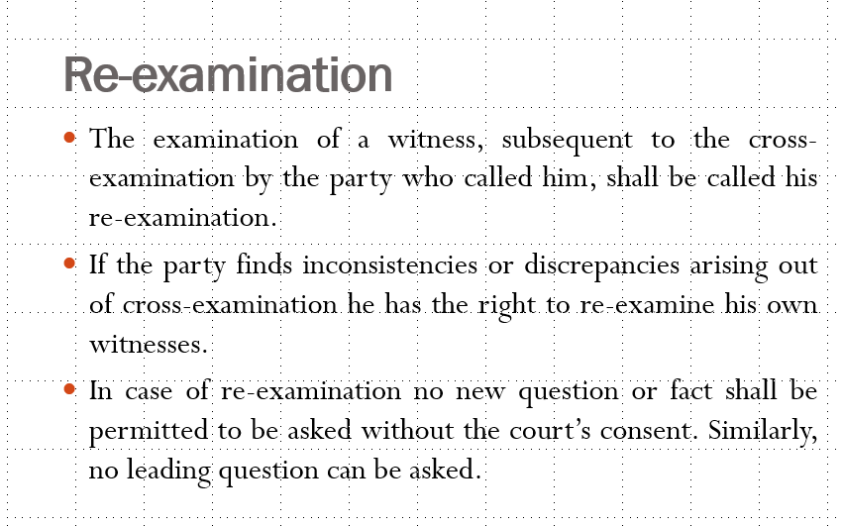

**ADMISSION AND CONFESSION UNDER BSA 2023**

**Section 15 to Section 21 of BSA** covers all the provisions related to admissions under BSA.

**Admission**

* Admission plays a very important role in judicial proceedings. If one party to the suit or any other proceeding proves that the other party has admitted his case, the work of court becomes easier.
* The expression 'Admission' means "Voluntarily acknowledgment of the existence or truth of a particular fact".
* In BSA, the term 'Admission' has not been used in this wider sense.  It deals with admissions by statements only oral or written or contained in an electronic form.  But an Admission must be clear, precise and not vague or ambiguous.

**Definition of Admission**

* Admission is defined under Section 15 of BSA as a **statement made by witnesses** which shows inference to any fact in issue or relevant fact in a case.
* According to Section 15, admission can be in the form of a **document, oral statement or may be contained in an electronic form.**

**Parties who can Make the Admissions**

According to **Section 16 of BSA**, the following parties can make admissions:

* **Admission by Parties to Proceeding:**
  + The term ‘parties’ not only means the persons who appear on the record in that capacity but also includes those persons who are parties to a suit without appearing.
  + Persons who have an interest in the subject matter of the suit but are not parties on the record are also considered as parties in the proceedings and their statements.
* **Admission by Agent:**
  + The statements made by an agent in a suit would be admissible as against the person he is representing.
  + The statements made by an agent are, however, binding only when they are made during the continuation of his agency.
* **Statements made in Representative Character:**
  + When a person such as trustees, administrators, executors etc., sue or are sued in a representative character.
  + Any statement made by them will only be admissible if made in their representative character. Any declarations made by them in their personal capacity will not be taken as an admission.
* **Persons interested in the Subject-matter:**
  + In any such suit where several persons are interested jointly in the subject-matter of the suit, then any admission made by anyone of the parties will be taken as an admission against himself as well as the other parties jointly interested in the subject matter.
* **Persons from whom the Parties derive Interest:**
  + Any statement made by the predecessor-in-title from whom the party to the suit derives his title will be admissible.
  + But this will only be held as an admission if the predecessor-in-title made the declaration while still holding the title and not after the title has been transferred.
  + The statement made by the former owner will not be considered as an admission as against the parties if it was made title has been passed.

**Confession under Bharatiya Sakshya Adhiniyam 2023**

A confession is a voluntary statement made by an accused person admitting guilt or involvement in a crime. It is a powerful piece of evidence that can lead to a conviction. However, its admissibility is strictly regulated due to the potential for coercion or inducement. To be admissible, a confession must be freely and voluntarily made, without any undue influence or threat. The law places a heavy burden on the prosecution to prove that a confession is voluntary before it can be presented as evidence in court.

**Types of Confessions Under the Bharatiya Sakshya Adhiniyam, 2023**

The Bharatiya Sakshya Adhiniyam, 2023, primarily focuses on the admissibility of confessions in criminal proceedings. Key types include:

1. **Admissible Confessions:** These are confessions that can be used as evidence in court. They include those made voluntarily, without inducement, threat, or promise, and those recorded in the presence of a magistrate when the accused is in police custody.
2. **Inadmissible Confessions:** These are confessions that cannot be used as evidence. They primarily include confessions made to a police officer, whether in or out of custody, as they are considered unreliable due to potential coercion.
3. **Confessions Leading to Discovery:** While confessions to police officers are generally inadmissible, if a confession leads to the discovery of evidence, the evidence itself may be admissible. However, the confession remains inadmissible.

**Importance of Confession under the Bharatiya Sakshya Adhiniyam, 2023**

* Confessions hold significant importance in the realm of criminal law and evidence. Under the Bharatiya Sakshya Adhiniyam, 2023, a confession is a voluntary statement made by an accused admitting guilt or involvement in a crime. While it can be a powerful piece of evidence, the law places strict safeguards to ensure its admissibility.
* Confessions can expedite the judicial process by providing direct evidence of guilt, saving time and resources. However, the Act emphasizes the voluntary nature of confessions, excluding those obtained through coercion, inducement, or threat.
* This protection ensures the reliability and fairness of the judicial process. Additionally, the law allows for the admission of portions of a confession related to discovered facts, even if the entire statement is inadmissible, striking a balance between protecting the accused and aiding in the investigation.
* Ultimately, the importance of confessions lies in their potential to establish guilt while upholding the principles of justice and fairness enshrined in the Bharatiya Sakshya Adhiniyam, 2023.